**Project Documentation**

**Students:**Boian Maria,Stef Ioan-Alexandru

**Group:**30433

1.Objectives

Our objective is to create an application that controls and moves the robot with the help of WI-Fi module and displays the data read on the robot’s sonar sensor in an interface created in Python.

2.Hardware scheme&components

No additional hardware components were required.

2.1.Hardware scheme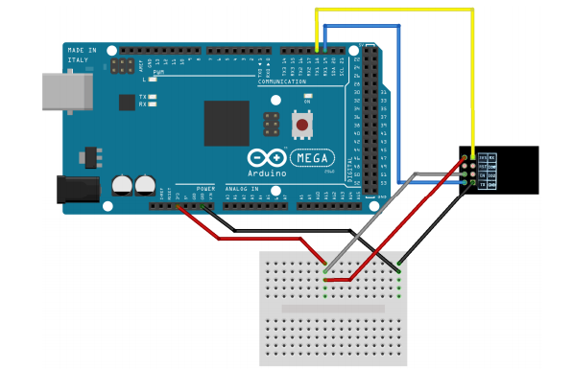

2.2.Components(baud rate 115200)

2.2.1.DC motors

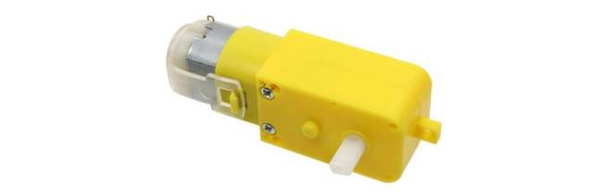

2.2.2.Servo motors

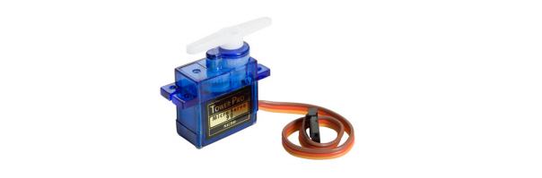

2.2.3.The experimental robot

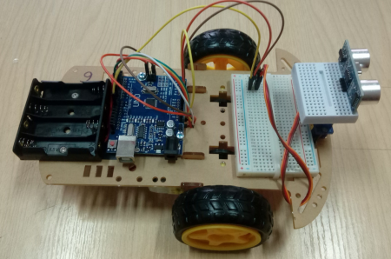

2.2.4.Sonar sensor

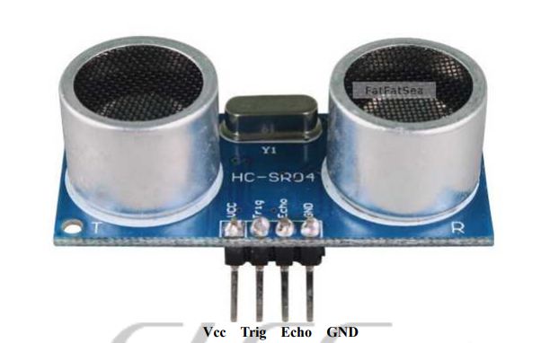

3.Alghorithm

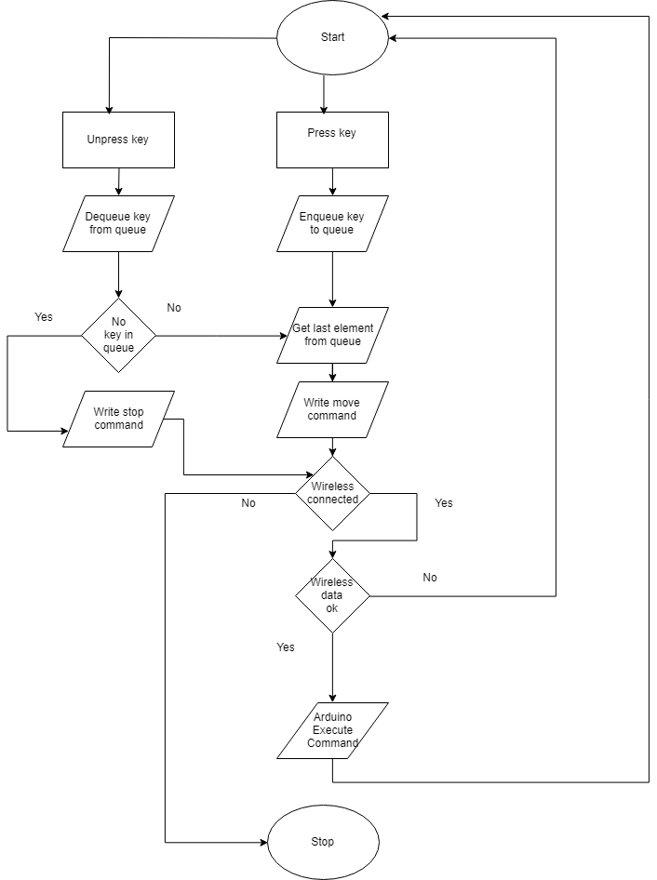

4.Results

The robot is moved using the W,A,S,D kewboard keys and the servo motor by up,down,left and right keyboard keys.The distance is expressed in cm and is displayed on the screen, in the Python interface.The sonar sensor can only read a minimum distance of 30 cm. Because of this , the robot is difficult to use in small spaces.

5.Conclusions

This project can be further developed to an application that finds the exit out of a room by mapping a map to it.